IDENTIFYING & NON- IDENTIFYING

CREATE TABLE dept(

deptno INT NOT NULL,

dname INT NOT NULL,

PRIMARY KEY (deptno),

);

CREATE TABLE emp (

emp_id INT NOT NULL,

ename INT NOT NULL,

deptno int ,

PRIMARY KEY (emp_id ),

FOREIGN KEY (deptno) REFERENCES dept(deptno)

);

CREATE TABLE emp_phone (

emp_id INT NOT NULL,

phone_id INT NOT NULL,

PRIMARY KEY (emp_id, phone_id),

FOREIGN KEY (emp_id) REFERENCES emp(emp_id)

);

Identifying Relationship Non-Identifying Relationship

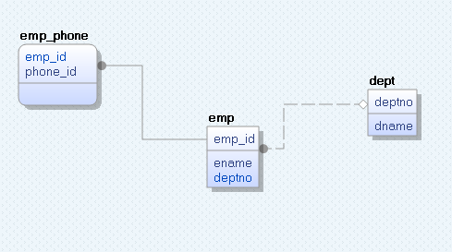

* The Logical Model: You can create an independent logical model, with unique notation and display options.
* The Physical Model: You can create an independent physical model with unique notation and display options.
* The Logical/Physical Model: You can create a new model with a combined logical and physical components.